AAT LAB 2
Name : Swarangi Kothawade
Div/Roll No. : A-34

SELECTION SORT
#include <bits/stdc++.h>
using namespace std;

void swap(int *xp, int *yp)
{
int temp = *xp;
*xp = *yp;
*yp = temp;
}

void selectionSort(int arr[], int n)
{
int i, j, min_idx;
for (i = 0; i < n-1; i++)
{

min_idx = i;
for (j = i+1; j < n; j++)
if (arr[j] < arr[min_idx])
min_idx = j;

swap(&arr[min_idx], &arr[i]);
}
}

void printArray(int arr[], int size)
{
int i;
for (i=0; i < size; i++)
cout << arr[i] << " ";
cout << endl;
}

int main()
{
int arr[] = {64, 25, 12, 22, 11};
int n = sizeof(arr)/sizeof(arr[0]);
selectionSort(arr, n);
cout << "Sorted array: ";
printArray(arr, n);
return 0;
}

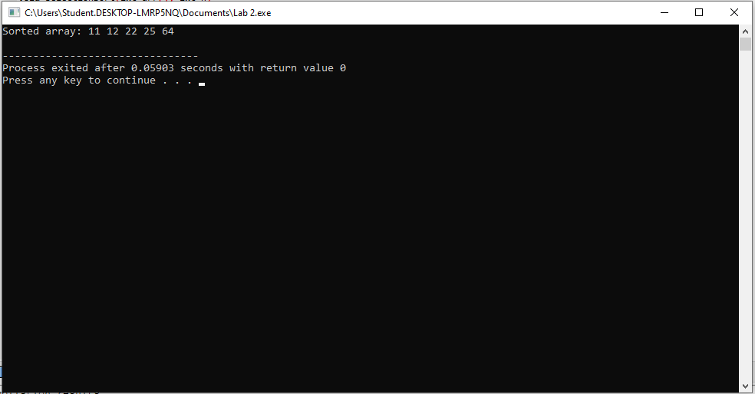
INSERTION SORT
#include <iostream>
using namespace std;

void insertionSort(int arr[], int n)
{
for (int i = 1; i < n; ++i) {
int key = arr[i];
int j = i - 1;

while (j >= 0 && arr[j] > key) {
arr[j + 1] = arr[j];
j = j - 1;
}
arr[j + 1] = key;
}
}

void printArray(int arr[], int n)
{
for (int i = 0; i < n; ++i)
cout << arr[i] << " ";
cout << endl;
}

int main()
{
int arr[] = { 12, 11, 13, 5, 6 };
int n = sizeof(arr) / sizeof(arr[0]);

insertionSort(arr, n);
printArray(arr, n);
return 0;
}

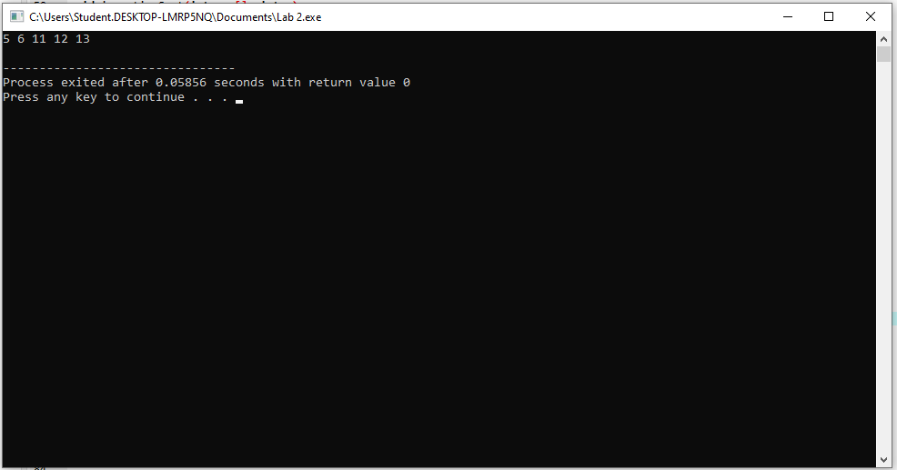

BUBBLE SORT
#include <iostream>
#include <conio.h>

using namespace std;

int main()
{
int num[]= {12,9,37,86,2,17,5};
int i,j,t;

cout<<"Array before Bubble Sort"<<endl;
for(i=0; i<7; i++)
{
cout<<num[i]<<" ";
}

for(i=0; i<6; i++)
{
for(j=0; j<6-i; j++)
{
if(num[j]>num[j+1])
{
t=num[j];
num[j]=num[j+1];
num[j+1]=t;
}
}
}

cout<<"\n\nArray after Bubble Sort\n";
for(i=0; i<7; i++)
{
cout<<num[i]<<" ";
}
return 0;
}
